PUA LILILEHUA Mary Puku‘i & Kahauanu Lake

INTRO 2 Vamps D7 G7 C D7 G7 C

C G7 C C7 F C G7
'Auhea wale ana 'oe, e ka pua lililehua
C E7 Am F C G7 C Vamp
A he ipo ho'ohenoheno, e ho'ohihi ai no ka mana'o
------------------------------------

C G7 C C7 F C G7
Ia 'oe e 'imi ana, i na nani o ka'aīna
C E7 Am F C G7 C Vamp
Eia no la au ma 'ane'i, e kali ana i kou ho'i mai
-------------------------------------

C G7 C C7 F C G7
E 'alawa mai ho'i 'oe, i nei mau maka onaona
C E7 Am F C G7 C Vamp
He mau maka poina 'ole, e kapalili ai ko pu'uwai
-------------------------------------

C G7 C C7 F C G7
Hilo pa'a 'ia ke aloha, i ka lino hilo pawalu
C E7 Am F C G7 C Vamp
A'ohe mea| e hemo ai, me a'u 'oe a mau loa
--------------------------------------

C G7 C C7 F C G7
Ha'ina mai ka puana, e ka pua lililehua
C E7 Am F C G7 C
A he ipo ho'ohenoheno, e ho'ohihi ai no ka mana'o

F C G7 C 2 X D7 G7 C G7 C
TAG e ho‘ohihi ai no ka mana‘o

This is to you, O sage blossom
A cherished sweetheart that attracts the mind

While you go seeking among the beauties of the land
Right here I remain, waiting for your return

Glance quickly this way at these inviting eyes
These unforgettable eyes that make your heart flutter

Love is bound fast, with an eight strand lei
There is nothing to separate you from me
Ma‘iki Aiu and Kehauanu Lake
This story is told for you, O sage blossom
A cherished sweetheart that attracts the mind
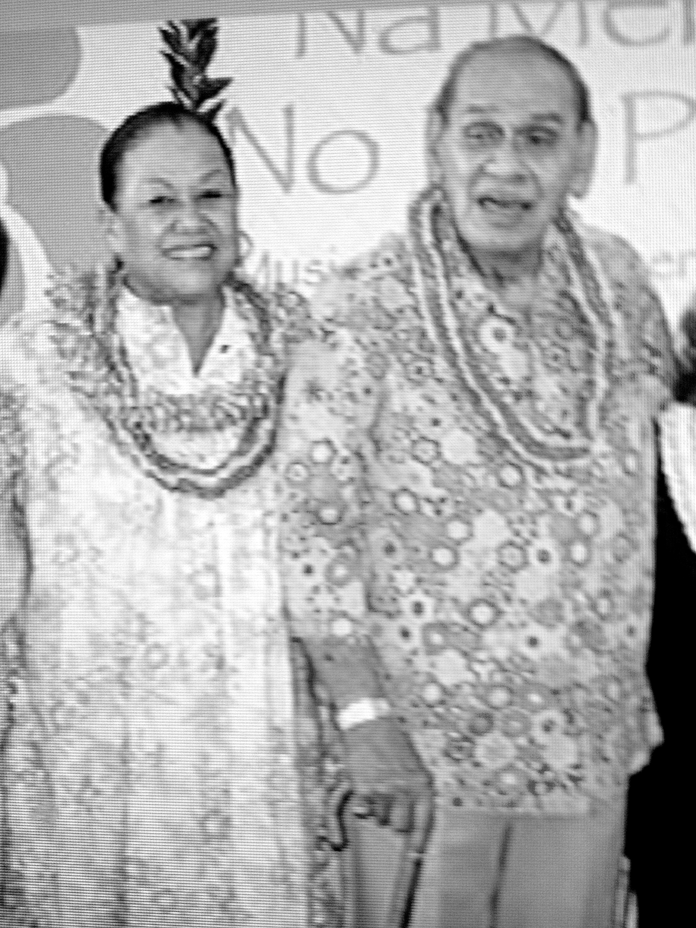

Famed musical artist Kahauanu Lake wrote this song to win the
heart of well known hula master Ma‘iki Aiu.
Ma‘iki was young when she graduated as Kumu Hula from famed hula expert Lokalia Montgomery. She began teaching right away – her halau was called Halau O Ma‘iki. She soon gained a favorable reputation for herself and her dancers, producing well-disciplined elegant performances at many of the better nightspots in Waikiki. Kahauanu Lake and his trio were well established and sought after in Waikiki, headlining at the Royal Hawaiian Hotel for many years.
The two groups worked together on many occasions and Mr. Lake fell in love with Ma‘iki. He decided to declare his love by writing this special song for her. Pua Lililehua means red sage brush flower – it’s also the name of the wind and rain in Palolo Valley where Ma‘iki lived as well as the name of a legendary maiden who resided in Palolo valley who was courted by a mo‘o. When the song was finished, he asked his mentor, Mary Kawena Puku‘i, to translate it into hawaiian. When it was complete, he asked Ma‘iki to create a hula for the new song, which she did. Only after the performance of the number did she find out that it was written for her.
The two married and performed together for many years.

